CMPS 312 Mobile App Development – Fall 2020

**Assignment 5**

|  |  |
| --- | --- |
| **Student Name** | Abdulla Khedr |
| **Student Id** | 201702167 |
| **Email** | Ak1702167@qu.edu.qa |

**Grading Rubric - - In the *Functionality* column please specify either: *Working (completed x%)*, *Not Working (completed x%)* or *Not done*.**

|  |  |  |  |  |
| --- | --- | --- | --- | --- |
| Criteria | % | Functionality* | Quality of the implementation | Student Score |
| Authentication | 15 | Working (completed 100%) |  |  |
| List Account by type | 15 | Working (completed 100%) |  |  |
| Delete Account and related transactions | 20 | Working (completed 100%) |  |  |
| Add account | 10 | Working (completed 100%) |  |  |
| Update Account | 15 | Working (completed 100%) |  |  |
| Add Transaction | 25 | Working (completed 100%) |  |  |
| Total | **100** |  |  |  |
| Not uploading Testing Sheet with screenshots | **-15** |  |  |  |
| Copying and/or plagiarism or not being able to explain or answer questions about the implementation | -100 |  |  |  |

**\* Possible grading for functionality**: ***Complete and*** ***Working*** (get 70% of the assigned grade), ***Complete and*** ***Not*** ***working*** (lose 60% of assigned grade) and ***Not done*** get 0. The remaining grade is assigned to the quality of the implementation. Must submit screenshots in **Testing-GradingSheet.docx** (otherwise -15pts).

**Add Screenshots**

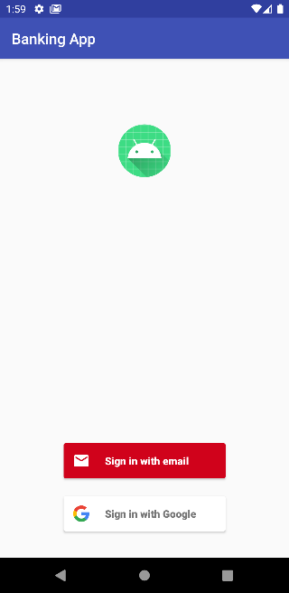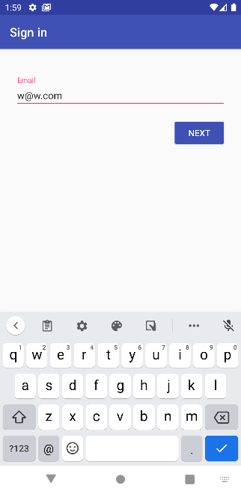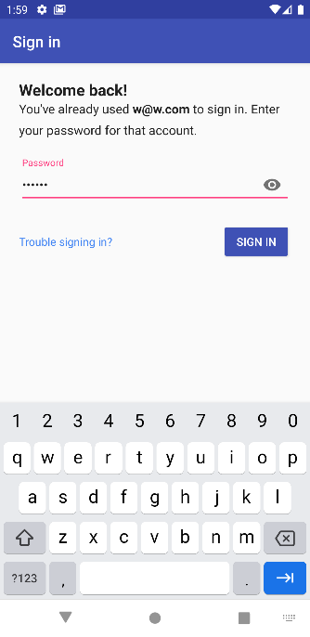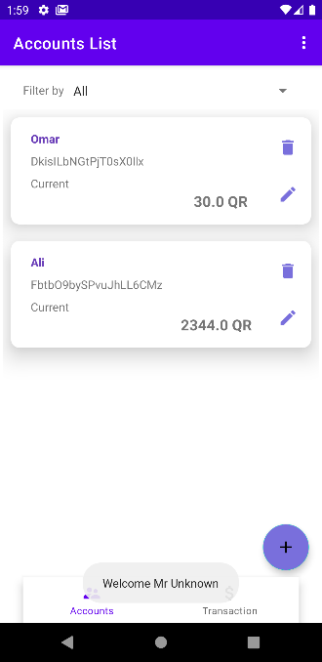**Auth:**

**Add account:**

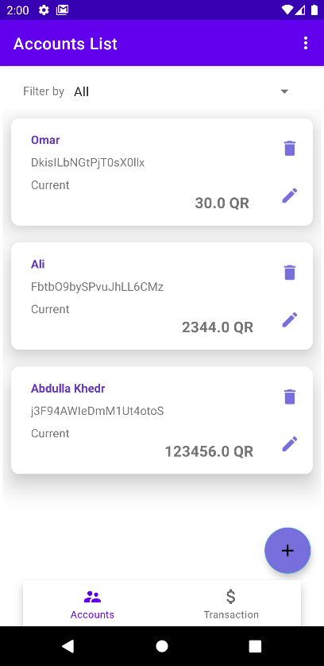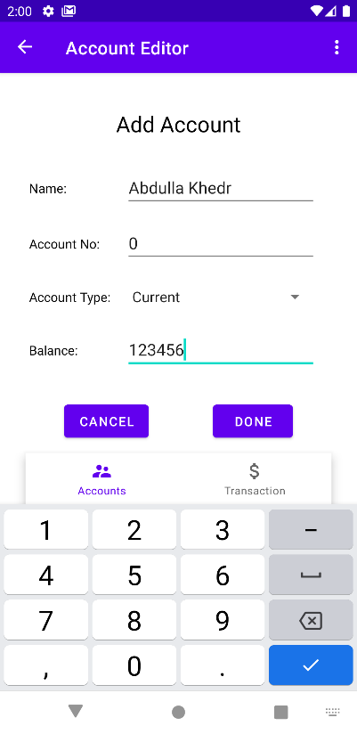

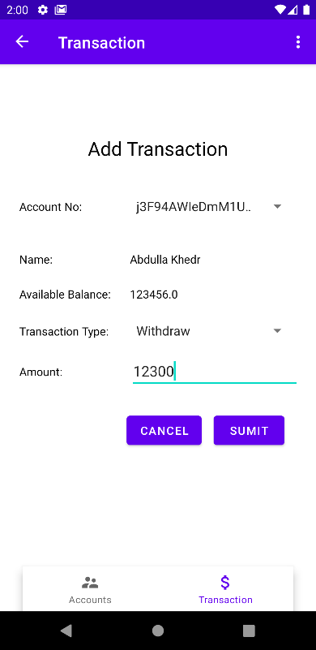**Transaction:**

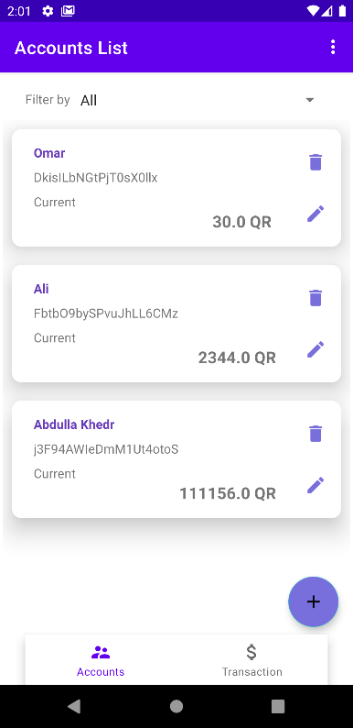

**Delete Accounts:**

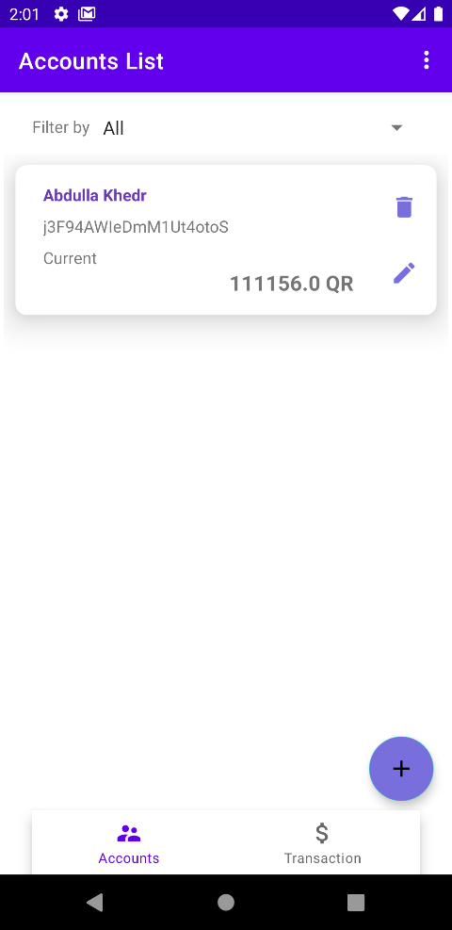

**Update Account:**

